CDS invoked ODATA QUERY Testing
ODATA created for CDS View works based on SADL exposure and we don’t need to write any custom implementation for the Querying.
SADL – Service Adaptation Definition Language.
1.Count Query
URI: http://172.35.0.26:8000/sap/opu/odata/sap/ZTRUPEN_ODATA_INVOKECDS_SRV/ZTRUPEN_SALES_ORDER('0000001946')/to_ITEM/$count
Output

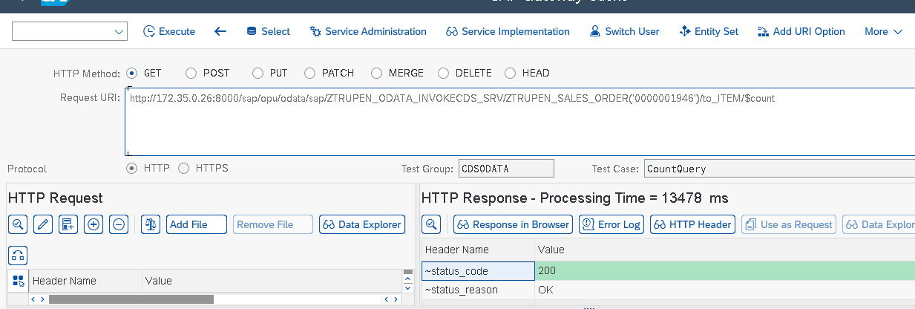
2.Expand Query
URI: http://172.35.0.26:8000/sap/opu/odata/sap/ZTRUPEN_ODATA_INVOKECDS_SRV/ZTRUPEN_SALES_ORDER('0000001946')?$expand=to_ITEM
Output
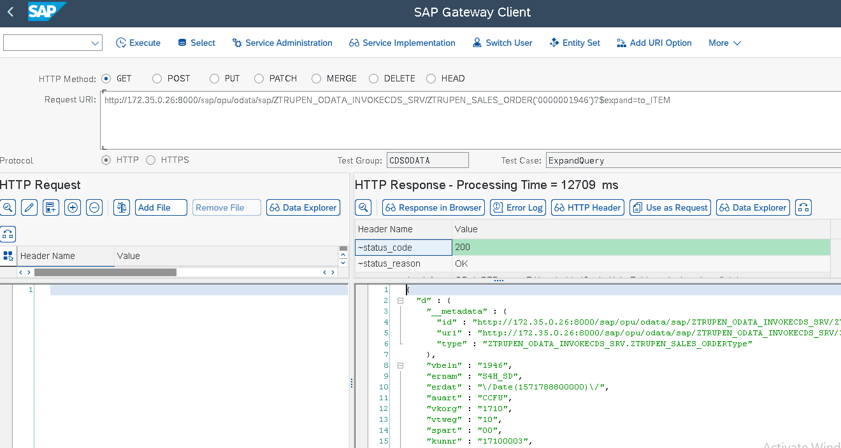
3.Filter Query
URI http://172.35.0.26:8000/sap/opu/odata/sap/ZTRUPEN_ODATA_INVOKECDS_SRV/ZTRUPEN_SALES_ORDER?$top=10&$filter=ernam eq 'SERV_MAN'
Output
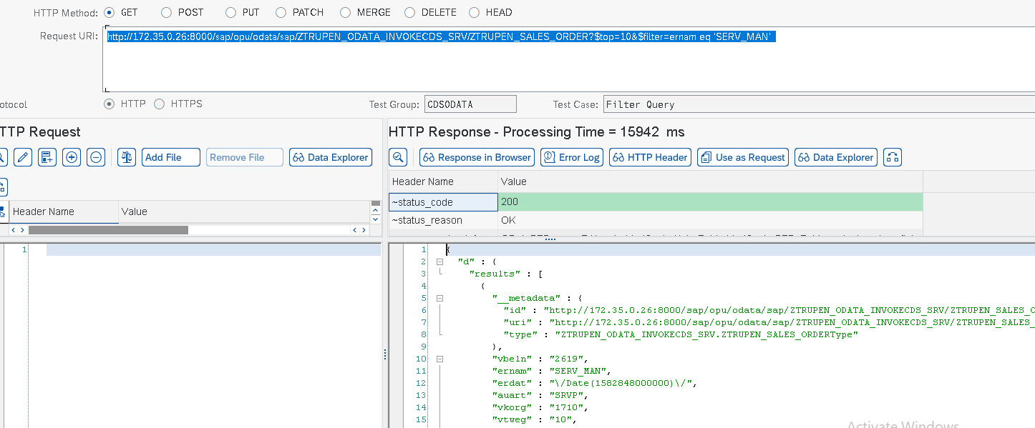
4.FORMAT Query:
URI http://172.35.0.26:8000/sap/opu/odata/sap/ZTRUPEN_ODATA_INVOKECDS_SRV/ZTRUPEN_SALES_ORDER?$format=json
Output
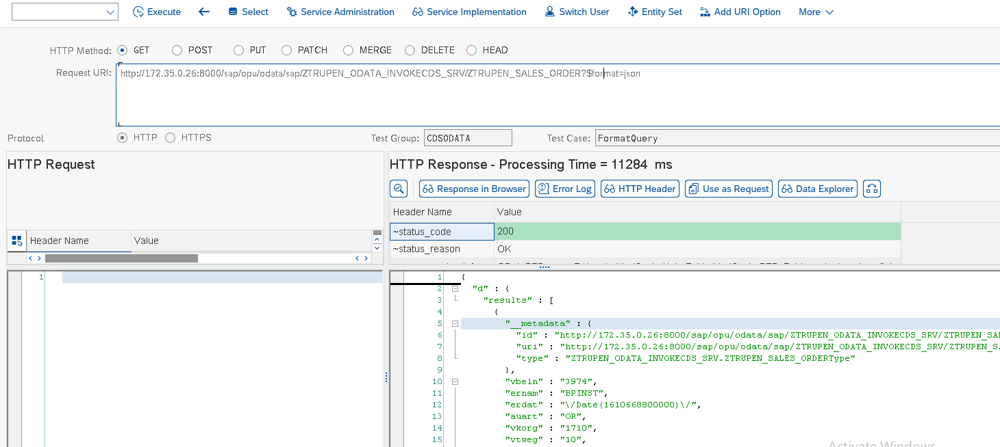

5.INLINE COUNT Query
URI
http://172.35.0.26:8000/sap/opu/odata/sap/ZTRUPEN_ODATA_INVOKECDS_SRV/ZTRUPEN_SALES_ORDER?$top=10&$filter=ernam eq 'SERV_MAN'&$inlinecount=allpages
Output
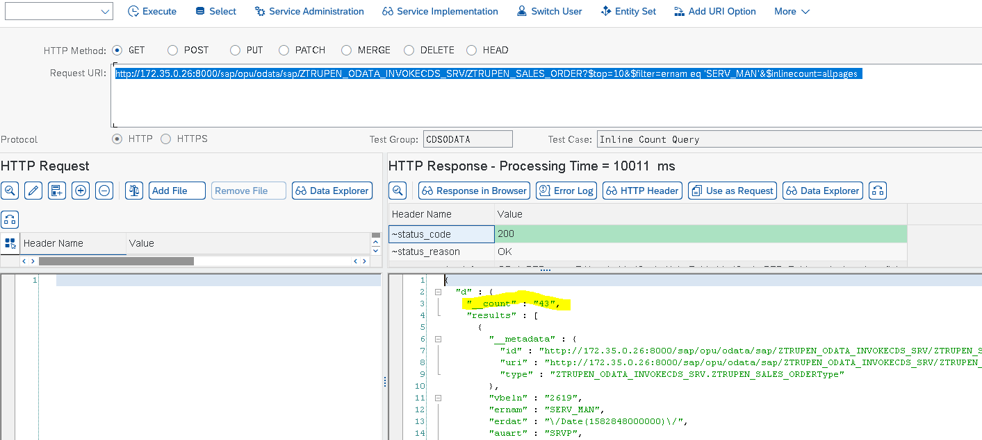
6.Links Query
URI http://172.35.0.26:8000/sap/opu/odata/sap/ZTRUPEN_ODATA_INVOKECDS_SRV/ZTRUPEN_SALES_ORDER('0000001946')/$links/to_ITEM
Output
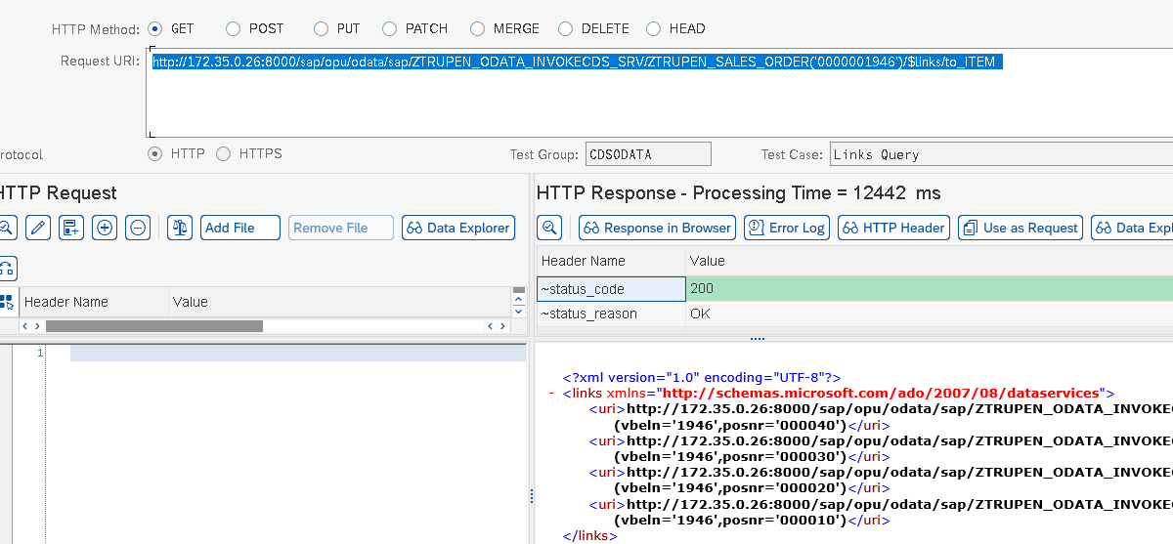

7.ORDER BY Query
URI http://172.35.0.26:8000/sap/opu/odata/sap/ZTRUPEN_ODATA_INVOKECDS_SRV/ZTRUPEN_SALES_ORDER?$top=10&$orderby=vbeln desc
Output
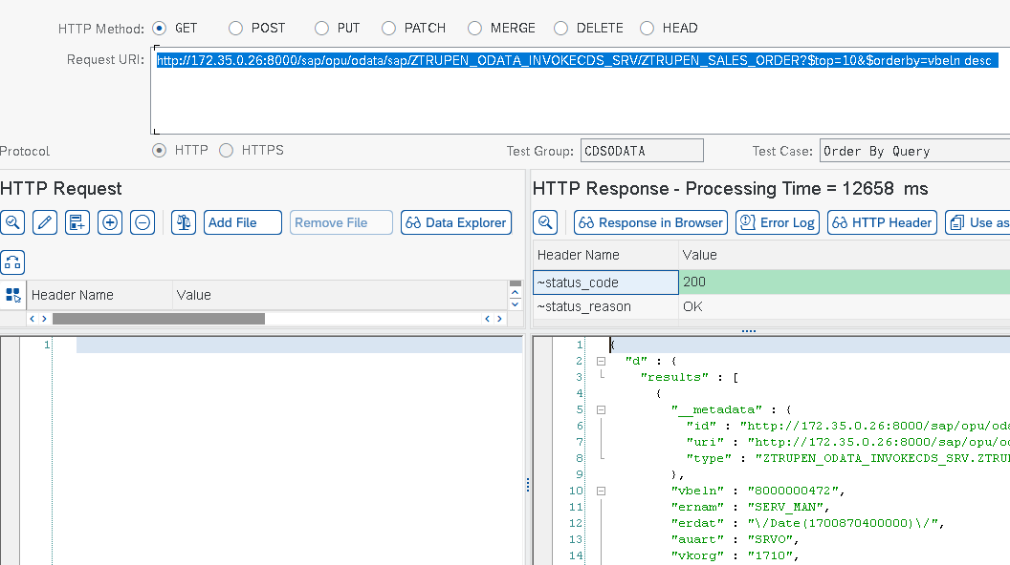
8.SELECT Query
URI
http://172.35.0.26:8000/sap/opu/odata/sap/ZTRUPEN_ODATA_INVOKECDS_SRV/ZTRUPEN_SALES_ORDER('0000001946')?$select=vbeln , ernam
Output
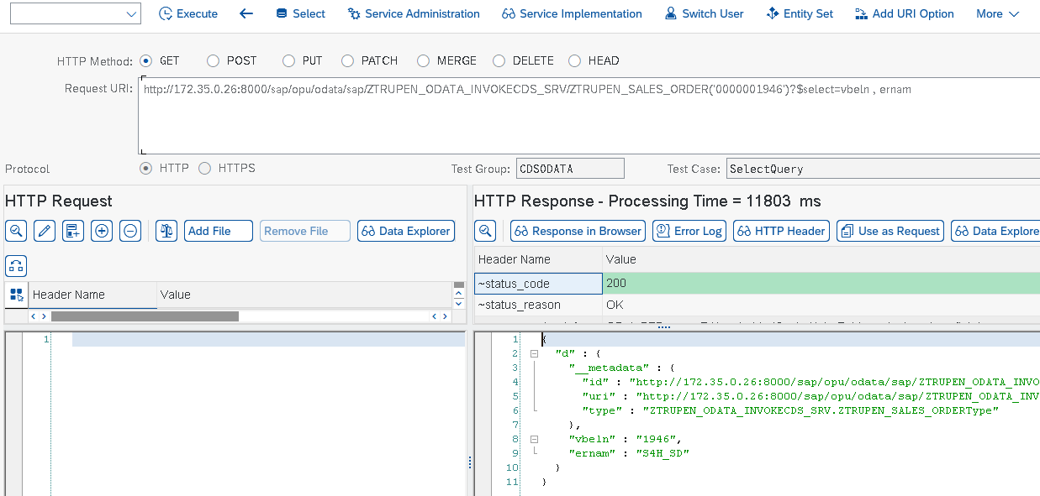

9.SKIP Query
URI http://172.35.0.26:8000/sap/opu/odata/sap/ZTRUPEN_ODATA_INVOKECDS_SRV/ZTRUPEN_SALES_ORDER?$top=10&$filter=ernam eq 'SERV_MAN'&$skip=2
Output
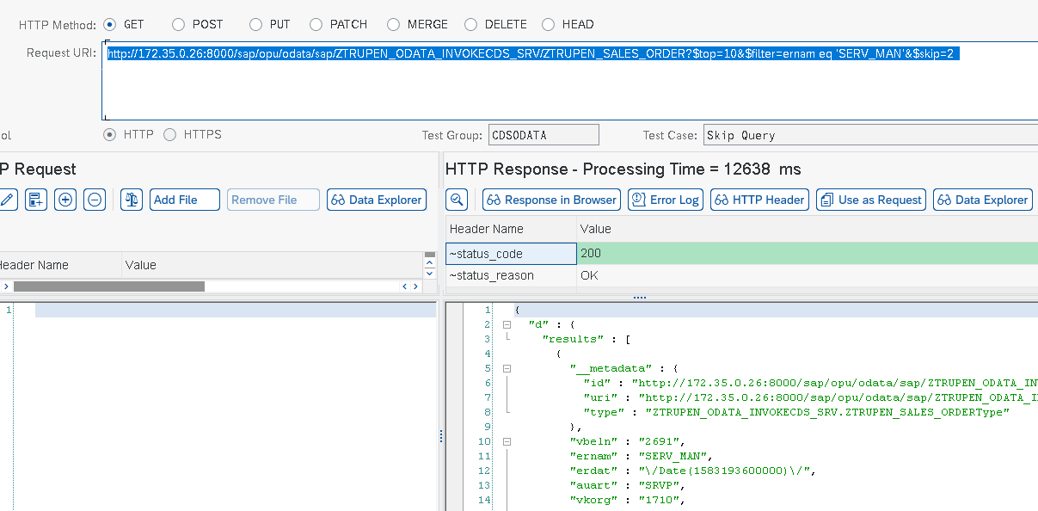

10.Top Query
URI
http://172.35.0.26:8000/sap/opu/odata/sap/ZTRUPEN_ODATA_INVOKECDS_SRV/ZTRUPEN_SALES_ORDER?$top=10
Output
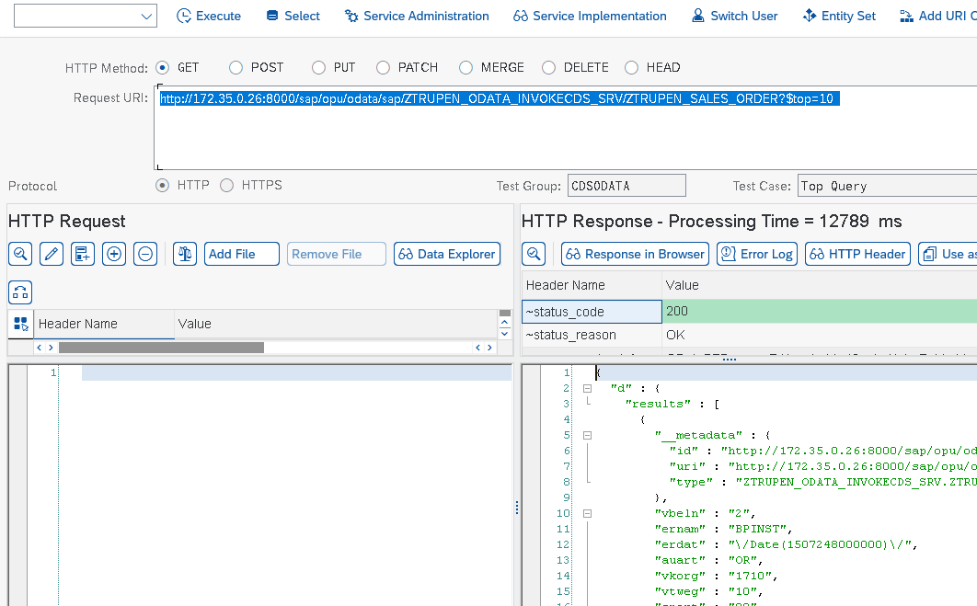
11.Value Query
URI
http://172.35.0.26:8000/sap/opu/odata/sap/ZTRUPEN_ODATA_INVOKECDS_SRV/ZTRUPEN_SALES_ORDER('0000001946')/ernam/$value
Output
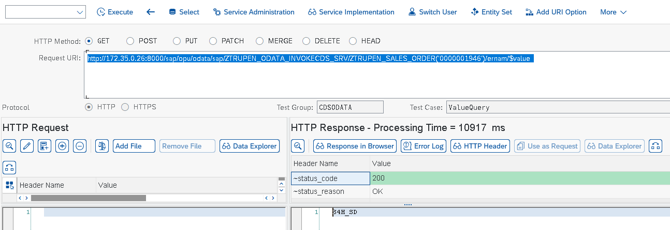
Manual ODATA Creation without any CDS View Requires Custom Logic Implementation for Handling certain Queries and to provide results.
- $orderby
- $top
- $skip
- $filter
- $inlinecount

